Bandwidth Delay Product

1. The bandwidth-delay product defines the number of bits that can fill the link.
2. It is the capacity of the link.
3. 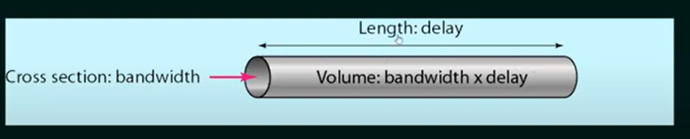
4. Example: 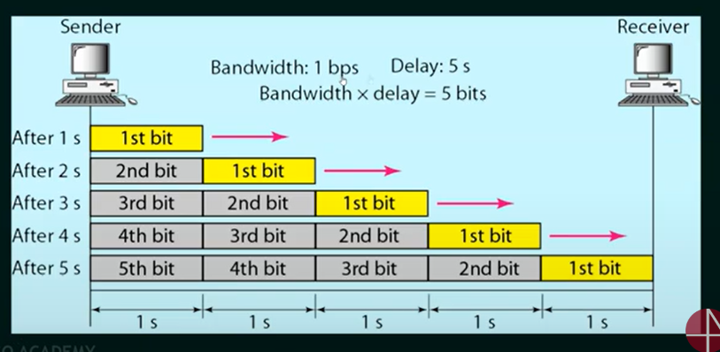
5. Solved example: 